**Day5-Selenium WebHandlers**

**QUESTION-1:**

**package** com.Test.Day5;

**import** org.openqa.selenium.By;

**import** org.openqa.selenium.WebDriver;

**import** org.openqa.selenium.WebElement;

**import** org.openqa.selenium.chrome.ChromeDriver;

**import** org.openqa.selenium.chrome.ChromeOptions;

**import** org.openqa.selenium.interactions.Actions;

**import** io.github.bonigarcia.wdm.WebDriverManager;

**public** **class** CE1 {

**public** **static** **void** main(String args[]) {

ChromeOptions co=**new** ChromeOptions();

co.addArguments("--remote-allow-origins=*");

WebDriverManager.*chromedriver*().setup();

WebDriver driver=**new** ChromeDriver(co);

driver.get("https://demoqa.com/droppable/");

driver.manage().window().maximize();

WebElement drag=driver.findElement(By.*id*("draggable"));

WebElement drop =driver.findElement(By.*id*("droppable"));

Actions a=**new** Actions(driver);

a.dragAndDrop(drag, drop).build().perform();

}

}

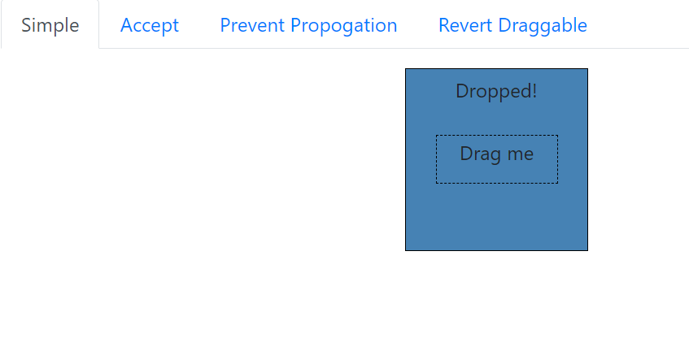

**QUESTION-2:**

**package** com.Test.Day5;

**import** org.openqa.selenium.By;

**import** org.openqa.selenium.WebDriver;

**import** org.openqa.selenium.WebElement;

**import** org.openqa.selenium.chrome.ChromeDriver;

**import** org.openqa.selenium.chrome.ChromeOptions;

**import** org.openqa.selenium.interactions.Actions;

**import** io.github.bonigarcia.wdm.WebDriverManager;

**public** **class** CE2 {

**public** **static** **void** main(String[] args) {

ChromeOptions co=**new** ChromeOptions();

co.addArguments("--remote-allow-origins=*");

WebDriverManager.*chromedriver*().setup();

WebDriver driver=**new** ChromeDriver(co);

driver.get("https://jqueryui.com/droppable/");

driver.manage().window().maximize();

driver.switchTo().frame(0);

driver.manage().window().maximize();

WebElement drag=driver.findElement(By.*id*("draggable"));

WebElement drop =driver.findElement(By.*id*("droppable"));

Actions a=**new** Actions(driver);

a.dragAndDrop(drag, drop).build().perform();

}

}

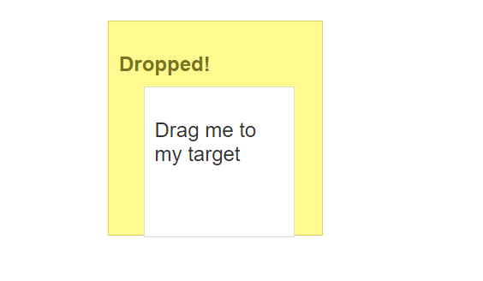

**QUESTION-3:**

**package** com.Test.Day5;

**import** org.openqa.selenium.Alert;

**import** org.openqa.selenium.By;

**import** org.openqa.selenium.WebDriver;

**import** org.openqa.selenium.chrome.ChromeDriver;

**import** org.openqa.selenium.chrome.ChromeOptions;

**import** org.openqa.selenium.WebElement;

**import** io.github.bonigarcia.wdm.WebDriverManager;

**public** **class** CE3 {

**public** **static** **void** main(String args[]) **throws** InterruptedException {

ChromeOptions co=**new** ChromeOptions();

co.addArguments("--remote-allow-origins=*");

WebDriverManager.*chromedriver*().setup();

WebDriver driver=**new** ChromeDriver(co);

driver.get("https://demo.guru99.com/test/delete_customer.php");

driver.manage().window().maximize();

WebElement searchbar=driver.findElement(By.*xpath*("/html/body/form/table/tbody/tr[2]/td[2]/input"));

searchbar.sendKeys("401");

WebElement submit= driver.findElement(By.*xpath*("/html/body/form/table/tbody/tr[3]/td[2]/input[1]"));

submit.click();

Alert alert1=driver.switchTo().alert();

Thread.*sleep*(3000);

alert1.dismiss();

searchbar.clear();

searchbar.sendKeys("402");

submit.click();

Alert alert2=driver.switchTo().alert();

alert2.accept();

Alert alert3=driver.switchTo().alert();

String txt=alert3.getText();

alert3.accept();

System.***out***.print(txt);

}

}

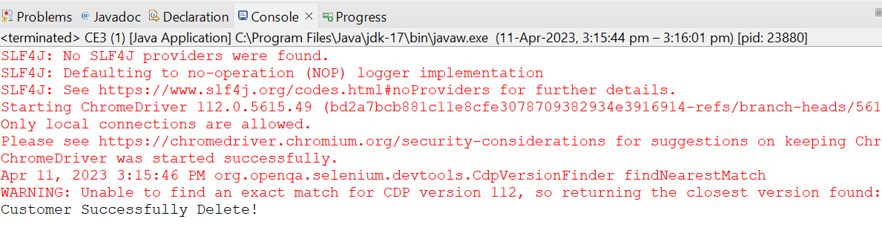

**QUESTION-4:**

**package** com.Test.Day5;

**import** org.openqa.selenium.By;

**import** org.openqa.selenium.WebDriver;

**import** org.openqa.selenium.chrome.ChromeDriver;

**import** org.openqa.selenium.chrome.ChromeOptions;

**import** org.openqa.selenium.support.ui.Select;

**import** io.github.bonigarcia.wdm.WebDriverManager;

**public** **class** CE4 {

**public** **static** **void** main(String args[]) {

ChromeOptions co=**new** ChromeOptions();

co.addArguments("--remote-allow-origins=*");

WebDriverManager.*chromedriver*().setup();

WebDriver driver=**new** ChromeDriver(co);

driver.get("https://www.abhibus.com/bus-ticket-booking");

driver.manage().window().maximize();

driver.findElement(By.*xpath*("//*[@id=\"datepicker1\"]")).click();

driver.findElement(By.*xpath*("//*[@id=\"ui-datepicker-div\"]/div[1]/table/tbody/tr[3]/td[7]/a")).click();

driver.findElement(By.*xpath*("//*[@id=\"source\"]")).sendKeys("Coimbatore");

driver.findElement(By.*xpath*("//*[@id=\"destination\"]")).sendKeys("Chennai");

}

}

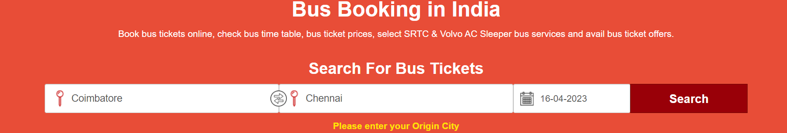

**QUESTION-5:**

**package** com.Test.Day5;

**import** org.openqa.selenium.By;

**import** org.openqa.selenium.Keys;

**import** org.openqa.selenium.WebDriver;

**import** org.openqa.selenium.WindowType;

**import** org.openqa.selenium.chrome.ChromeDriver;

**import** org.openqa.selenium.chrome.ChromeOptions;

**import** io.github.bonigarcia.wdm.WebDriverManager;

**public** **class** CE5 {

**public** **static** **void** main(String[] args) {

ChromeOptions co=**new** ChromeOptions();

co.addArguments("--remote-allow-origins=*");

WebDriverManager.*chromedriver*().setup();

WebDriver driver=**new** ChromeDriver(co);

driver.get("https://www.google.com");

driver.manage().window().maximize();

driver.findElement(By.*name*("q")).sendKeys("Apple");

driver.findElement(By.*name*("q")).sendKeys(Keys.***ENTER***);

System.***out***.println(driver.getWindowHandle());

System.***out***.println(driver.getTitle());

driver.switchTo().newWindow(WindowType.***TAB***);

driver.get("https://www.google.com");

driver.manage().window().maximize();

driver.findElement(By.*name*("q")).sendKeys("Selenium");

driver.findElement(By.*name*("q")).sendKeys(Keys.***ENTER***);

System.***out***.println(driver.getWindowHandle());

System.***out***.println(driver.getTitle());

driver.switchTo().newWindow(WindowType.***TAB***);

driver.get("https://www.google.com");

driver.manage().window().maximize();

driver.findElement(By.*name*("q")).sendKeys("Cucumber");

driver.findElement(By.*name*("q")).sendKeys(Keys.***ENTER***);

System.***out***.println(driver.getWindowHandle());

System.***out***.println(driver.getTitle());

}

}

